Malaria Research Business Case
Remi Hoff, Jennifer Simbulan, Noah Johnston, and Kevin Andreano
Group 5
INFO 584 SP23
Professor Eyyub Kibis
February 26, 2023

Table of contents

Abstract……………………………………………………………………………….3
Introduction/Motivation………………………………………………………………3
Data Set……………………………………………………………………………….4
Analysis……………………………………………………………………………….4
Results…………………………………………………………………………………5
Limitations of study and conclusion………………………………………………….14
References…………………………………………………………………………….15

Abstract
For our Malaria Research Business Case, a study was performed analyzing data pertaining to malaria and its prevalence worldwide. Through analysis, it was concluded that the mortality rate for malaria is on a downward trajectory but when studying the data further it was determined that the number of cases of malaria are still staying steady and are still affecting Africia more than any other region. We learned testing methods throughout the world vary and what testing method is more widely used and how important effective testing is in lowering death. Furthermore, it was discovered within Africa there were many different results between the countries. Our study found examples of effective preventative methods that help lower cases. The analysis below just scratches the surface and demonstrates the need for more extensive research into malaria infection prevention and treatments.
Introduction/Motivation
Malaria is a debilitating disease that has a massive toll on human health and is a problem that has been getting a lot of attention. As of 2020, there were an estimated 241 million people who had been diagnosed with Malaria, 95% of them being in Africa (Gates Foundation, 2022). It is a massive economic burden on those in low to middle income countries and will always act as a hindering factor to those economies until a solution is put into place that is accessible to the entire world. Solving this issue will allow these communities to become healthier and more prosperous.
When a mosquito bites an infected person, the small amount of blood taken from that person contains microscopic malaria parasites. When the mosquito then feeds again, the parasites are mixed with the mosquito’s saliva, infecting the next person. This parasite is found in red blood cells, and therefore if one is not careful, can be infected via blood transfusions, organ transplants or the shared use of needles (CDC, 2022).
The Bill & Melinda Gates Foundation is just one of the many foundations that are working towards ridding the world of this burden. Over the past two decades, The Gates Foundation has reduced the global burden of malaria, prevented 1.7 billion cases and saving 10.6 million lives. However, progress has slowed dramatically due to the continued threat of COVID-19 as well as drug and insecticide resistance and stagnant funding (Gates Foundation, 2022). The Gates Foundation believes that the only sustainable approach to addressing malaria is to eradicate the disease completely. The disease is treatable so if we are able to get to a point where we can provide the proper care, we can reach this goal.
As stated on The Gates Foundation website, their contributions account for less than 5% of the $4.3 billion invested annually into the fight against malaria. In order to maximize their contributions, they deploy their resources in areas where the efforts can be catalytic, take on risks that would be challenging for others to take, and focus on long-term objectives (Gates Foundation, 2022). The goal of our team’s analysis is to figure out exactly what areas are included within this category as well as determining what are the most influential factors that can help predict which areas this would include. The Gates Foundation has already invested in organizations that work on mapping the communities that are burdened by malaria to better identify the location, timing, and tools needed to fight it. Our team’s goal is to present to The Gates Foundation that we have useful data and that we should be one of the research organizations that they should invest in.

Data Set
In order to show a full picture of the many distinct types of research that can be done on malaria, we have used multiple datasets. For the first map figure below, a dataset collected from WHO was used. This dataset contained data from 2000-2017 and contained the number of cases and amount of deaths in each country around the world.
Using data compiled from the World Health Organization’s World Malaria Report 2021 (WMR), it gave us the ability to work with data that has been transformed and highly organized. We focused on the years 2000 through 2020 as the most recent data collected. The datasets from the WMR contained many different areas of interest. For our purposes we used information for the number of cases and mortality rates for malaria, funding for malaria control, and commodities distribution. The data was organized by WHO region classification, country and by the year. The data was all collected or compiled in October 2021.
Before the data could be analyzed in Tableau it was necessary to separate the region and country labels into two columns and bring the labels down to each year as they were blank in the csv file. By using one central data source the labels and formats were similar and there was not a need to transform the variables to match other data sets.
Because some of the data from the World Health Organization was contained in separate data files, it was necessary to join the files together in Tableau. This was the case with the mortality rate and total case data rate trend and country comparative visualizations below. By joining the files together in Tableau, it is possible to combine the two variables such as mortality rate and total estimated cases into the final visualizations.
Analysis
In analyzing the data, we started at a high level to gain context and draw general conclusions that might lead to additional questions. To do this, we started by looking at geographic and time series data to get a sense of where malaria burden was highest and what the overall trend was over time. Animating the data to create dynamic charts that change over time was helpful in visualizing the overall trends, and mapping the data helped to visualize this geographically. Having established this context, we sought to visualize the data in different ways that might shift our perspective. One way to do this was to look at mortality rate trends by country, revealing a plateauing trend and highlighting the need to zoom in further on specific countries of interest. This led to visualizations that allowed us to interactively examine the trend in each specific country. This in turn raised questions around where the trend might be going in the near future, prompting us to use Tableau forecasting features to visualize some potential future scenarios. Drilling in again to specific country information raised additional questions about other potential variables that might be impacting overall malaria trends such as access to insecticide treated nets, which we also visualized.
Our technique here was to look at malaria data sets from a very high level to first see if we can find any trends. Since temperature has a very large impact on Malaria, we can assume that the countries that have higher rates of Malaria have climates that allow the parasites to thrive and live during its entire growth cycle.
Results
Starting with the big picture, below is a visualization of the world using color as an indicator of the number of cases and deaths. The color of the country itself shows how many cases there were, and the circles show how many deaths occurred in the year 2017. The lighter the blue, the less cases there were and the brighter the red, the more deaths there were. As you can see from the graph below, there are only a few areas that had a large number of cases, which are mostly all in Africa. The number of deaths in Africa is also higher than anywhere else. 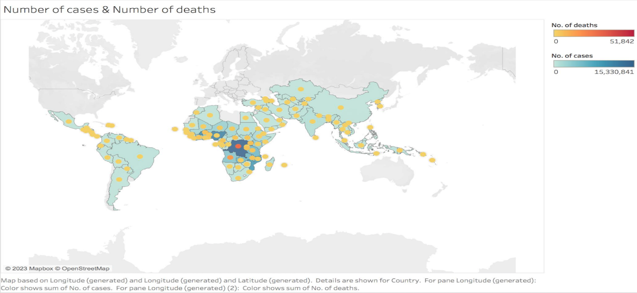

See our Tableau Public version of the graph above to be able to see the change in color throughout the years of 2000-2017:
https://public.tableau.com/authoring/MalariaCasesandDeaths2000-2017/Sheet1#1
By looking at the progression of the changes in the map from 2000-2017, it is easy to see that the cases were much lower in the year 2000. There were almost no dark blue or red circle areas, but once it hit around 2013, you can start to see the colors get darker.
Another way to view the cases is by region as seen in the packed bubble visualization below:
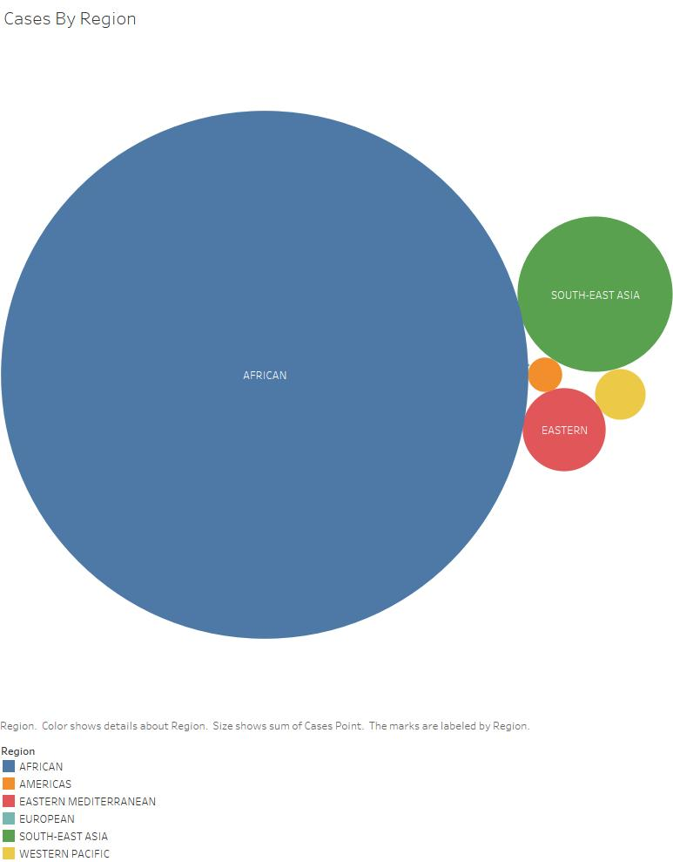
The above visualizations can help to provide insights into which regions have the heaviest malaria burden and describe general trends in total cases and deaths geographically over time. Visualizing the data in a different way can help to provide a different perspective on the overall trends that can help influence decision making around resource allocation. The chart below plots each country's mortality rate for the years between 2000 and 2020. Larger dots indicate higher caseloads, and the color becomes lighter as the mortality rate falls. In the previous visualization of cases and deaths on the map, it is possible to see a total reduction in malaria deaths. This visualization shows the same trend, with the mortality rate dramatically decreasing in many countries over the twenty-year period. However, this chart also clearly shows a plateauing in the most recent years, with mortality rates increasing in some countries in 2020. The countries with the worst mortality rates have fallen, but many countries are now clustered between 50 and 100 deaths per 100,000 population. This indicates that despite the significant progress in reducing malaria deaths, many countries are still experiencing large numbers of malaria deaths and will still require targeted assistance.
This trend can also be illustrated dynamically, as seen in the visualization on Tableau Public here:
https://public.tableau.com/shared/WHKN9W65X?:display_count=n&:origin=viz_share_link
This dynamic visualization shows malaria mortality rates falling as we move from 2000 to the late 2010s, when it appears that many countries hit a wall and start to bounce back up.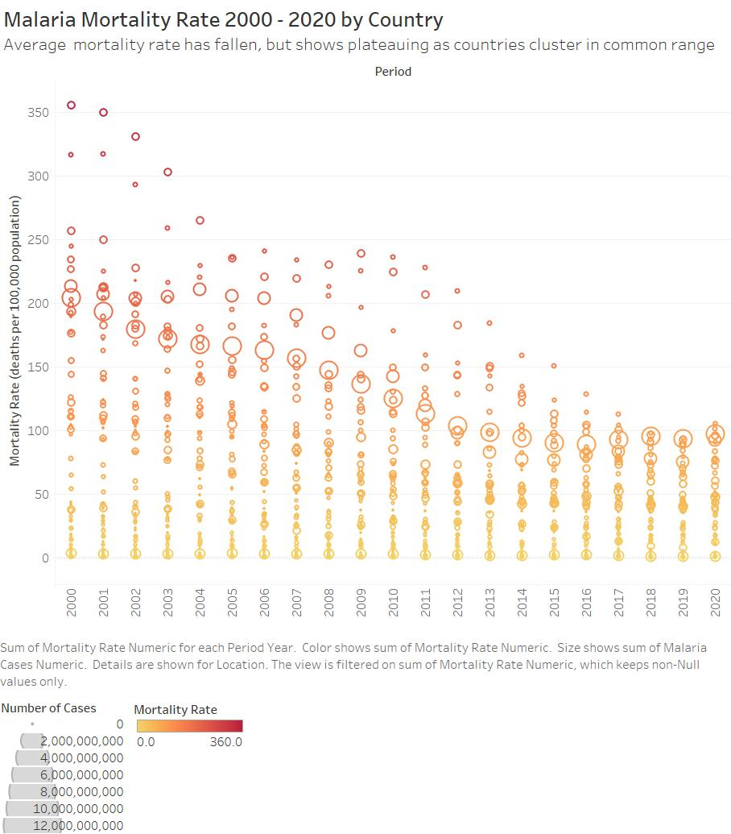

Understanding that specific countries are facing a barrier to continued decline in mortality rates, it is important to be able to look at data related to specific countries in more detail. To assist with this, we can create a dashboard that shows only a specific country or comparison group of countries as a line graph, to understand that specific mortality rate trend. Case load data is indicated visually by the thickness of the line. This approach allows the user to “zoom in” on specific countries dynamically to draw conclusions on a local level. A screenshot is below and the interactive dashboard can be found here: https://public.tableau.com/views/MalariaMortalityViz/Dashboard1?:language=en-US&publish=yes&:display_count=n&:origin=viz_share_link
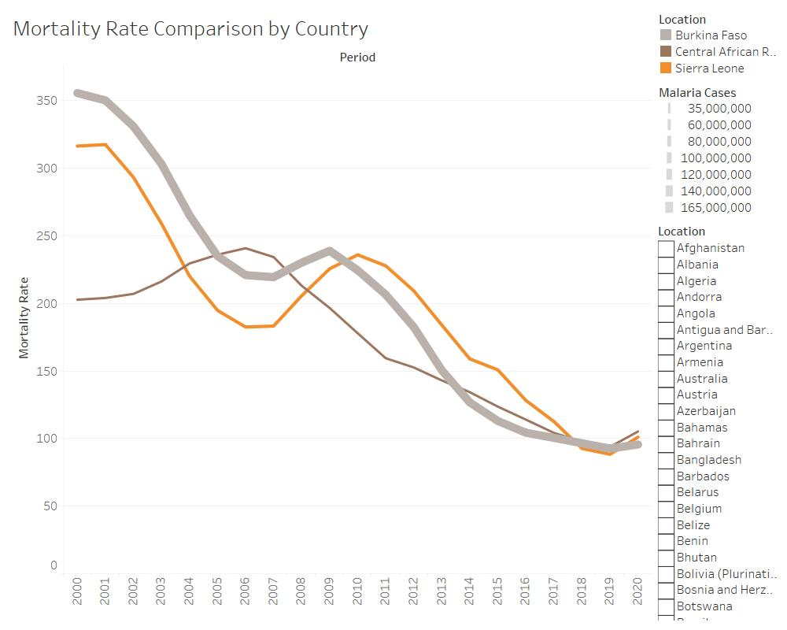
By using historical data, a forecast can be created to visualize the expected trend of worldwide cases and deaths for the years 2021 through 2024, as seen below. The cases represented by solid blue bars show a decline starting 2011 but still above two hundred twenty million cases. This trend is expected to continue as shown by the light blue bars in the graph. The overall trend of deaths declining is expected to continue and may reach under five hundred thousand deaths in the next three years as indicated by the light orange line.
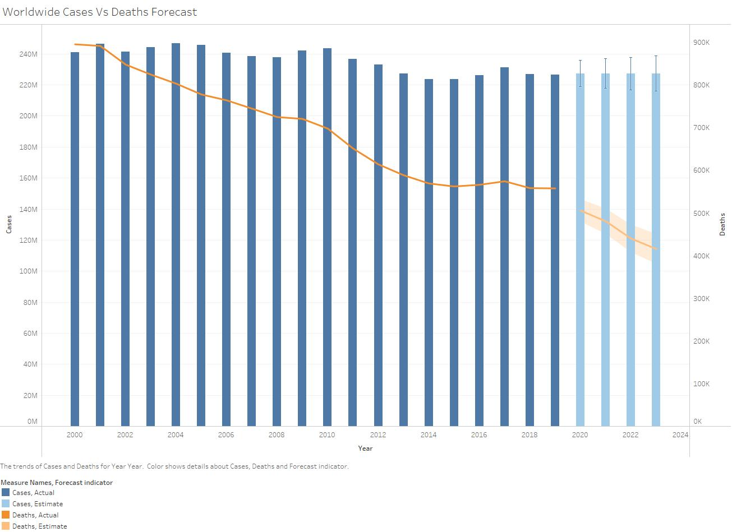
As the mortality rates are declining overall, when drilling down to a country-by-country basis as seen in the interactive Mortality Rate Comparison by Country Dashboard, it is clear that some countries are disproportionately affected by malaria deaths and cases. An example of this would be to compare Niger and Nigeria in Africa from 2000 through 2020 as seen below. Nigeria has seen decreases in their cases but a recent uptick in cases has resulted in an uptick in deaths as well. Niger has been able to maintain their number of deaths per year to under fifty thousand per year while Nigeria has between one hundred fifty thousand and two hundred thousand.
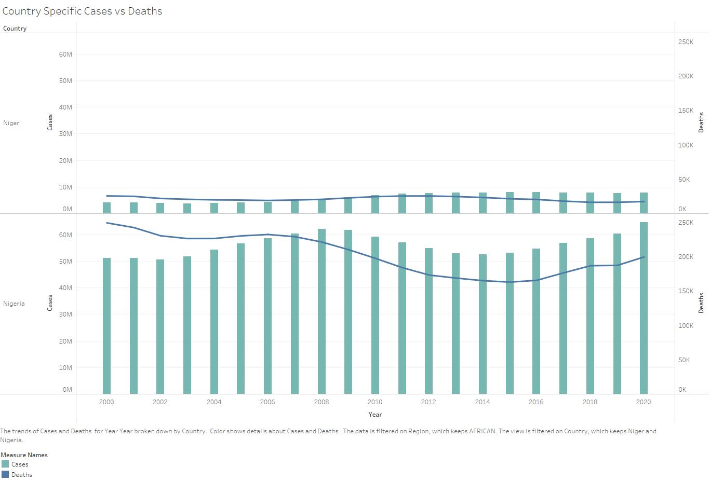
If cases increase the mortality rate will as well. There are effective treatments but also preventative measures that can be taken to prevent infection. Mosquito nets can be a very effective method and tool in fighting the spread of malaria. Insecticide-treated mosquito nets, indoor residual spraying and long-lasting insecticidal nets are a few examples of low cost and effective solutions. In the heat map below the percentage of the population with access to an insecticide treated net (ITN) is organized by African countries between 2018 and 2020. By 2020 Niger’s population has one of the highest populations with access to ITNs, while Nigeria’s population has half the access of Niger’s. This small but effective preventative measure has contributed to Niger’s ability to keep both their infections and mortality rate down.
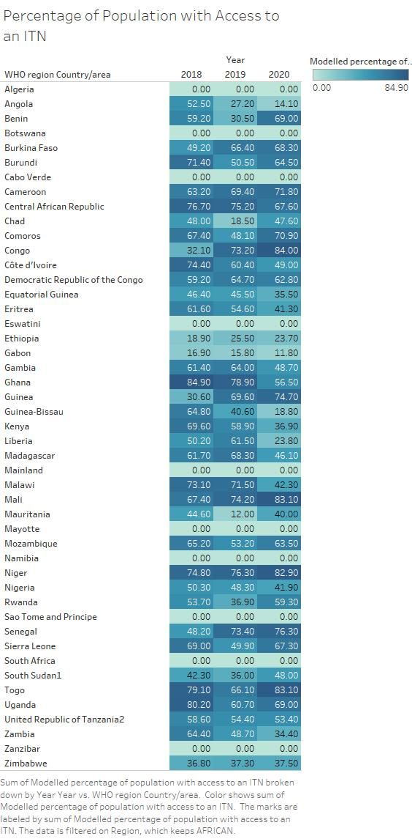
Malaria Testing by Region
There are two general forms of testing used to detect malaria: Microscopy and Rapid Diagnostic Tests (RDT). The Microscopy test has a greater sensitivity rating than RDT and is considered the more reliable test. It is considered “The Gold Standard '' for malaria testing, however it requires training and time to return the results. In areas of limited resources this becomes problematic and thus RDT becomes the preferred method in such areas. While not as accurate the RDT test is indeed rapid and easy to administer.
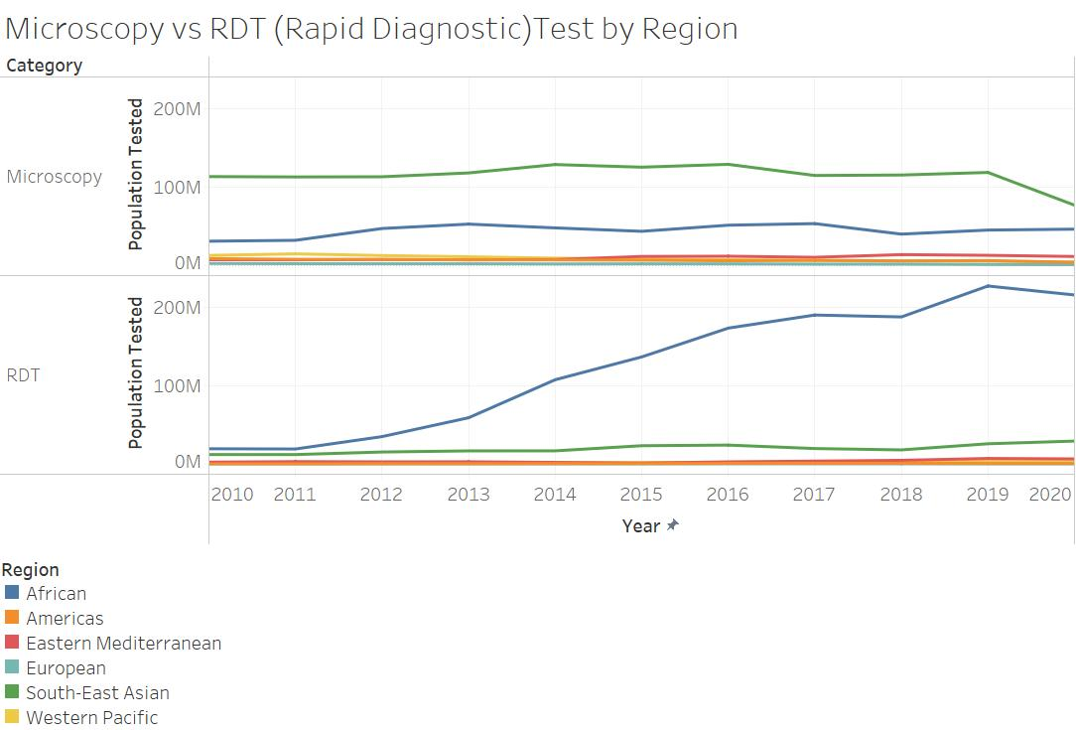
The RDT test is most often used in Africa by a prevailing margin and its use has steadily increased from 2011 to the present, peaking in 2019. Southeast Asia is where the majority of the world’s Microscopy tests occur and has kept a steady path, until dipping in 2019. While Africa does use the test as much, it has maintained a similar name of population tested in the last decade.
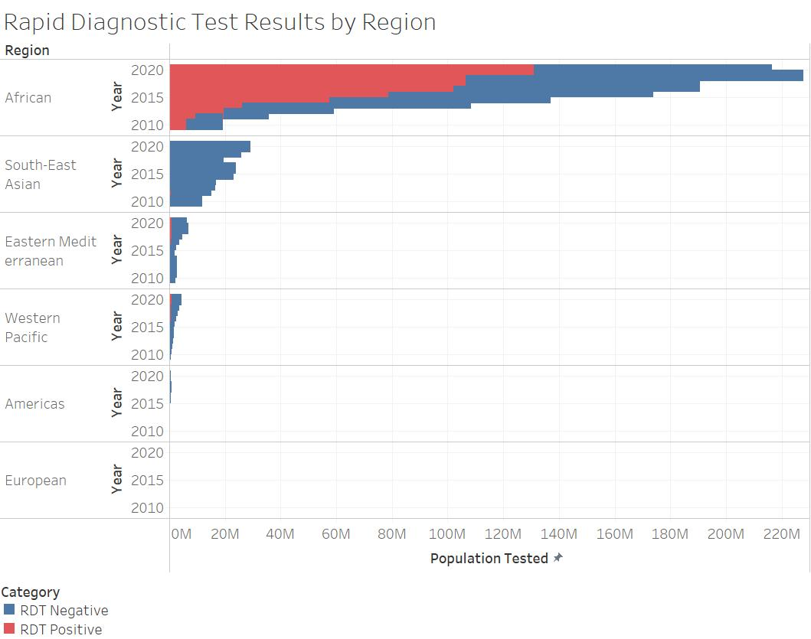
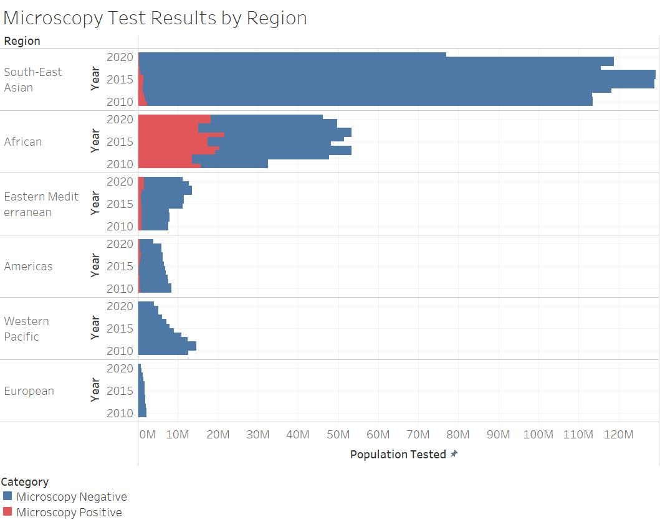
While Africa’s testing has increased, the number of positive results has increased along with it. In South-East Asia there has been a steady decline in positive results. Testing is not as widespread in other regions and positive results are minor. It is clear malaria still has a foothold in the African region. When looking at previously discussed visuals showing the decline of mortality rates and taking note of the increased testing above, we can infer that testing may play a very important role in identifying the disease to prevent loss of life in addition to putting the resources towards individuals that need to be treated vs those who do not.
Limitations of study and conclusion
As the World Health Organization has noted in their data collection notes in the past, there are limitations in the data quality for analysis of diagnostic testing and treatment information. This data is based on household surveys conducted by several health organizations. “The use of household survey data has several limitations. One issue is that, because of difficulty recalling past events, respondents may not provide reliable information, especially on episodes of fever and the identity of prescribed medicines, resulting in a misclassification of drugs” (World Malaria Report 2021, 2021). A way to improve this data collection method would be to implement reporting methods for healthcare providers to update their diagnosis and treatment plans at time of incident.

A limitation of our study was not including information on GDP, external health score data or environmental factors such as temperature and humidity. As this was an overview of the current state of malaria, we focused on establishing the progress being made and finding visualization tools that would aid in determining which countries need continued funding and intervention. As we narrow down our areas of concern going forward, external factors such as water quality, environment, government, funding, GDP, and many other factors can be used to determine where the attention should be focused.

Our study has found that the malaria mortality rate is on the decline, but the number of cases has remained steady for a twenty year period starting in 2000. Africa has the majority of cases and deaths worldwide but throughout the continent each country has very different rates. By looking at one preventive measure, ITN, we can see the effect it has on preventing cases and deaths.

Effective and accurate testing is essential in treating patients quickly. In 2020, the last year data was readily available on the internet, there was a slight uptick in deaths after it had been on a downward trend. Contributing factors could include healthcare funding being diverted to combat COVID-19, the healthcare infrastructures being overwhelmed by COVID-19 patients, or the isolation policy adopted by many countries during the pandemic delaying malaria treatments. This study demonstrates the need for continued research into combating the spread of malaria and why The Gates Foundation should allocate some of their investment funds to our organization. From the results above, we have proven that we have a good starting point and basis on the causes of malaria and the places where we should be deploying funds.

References
CDC - Malaria - about Malaria - Faqs. Centers for Disease Control and Prevention, Centers for Disease Control and Prevention, 22 Mar. 2022, https://www.cdc.gov/malaria/about/faqs.html#:~:text=When%20a%20mosquito%20bites%20an,into%20the%20person%20being%20bitten.
Malaria - Eradication, Prevention, through Innovation & Data. Bill & Melinda Gates Foundation, https://www.gatesfoundation.org/our-work/programs/global-health/malaria.
Malaria Burden Data: Cases and Deaths. World Health Organization, https://www.who.int/data/gho/data/themes/topics/topic-details/GHO/malaria-cases-deaths
World malaria report 2021. (2021, December 6). https://www.who.int/teams/global-malaria-programme/reports/world-malaria-report-2021
Comparison of Malaria Rapid Diagnostic Test Kit and Microscopy. (March 2019).
Scientific Research,
https://www.scirp.org/journal/paperinformation.aspx?paperid=91228

